LAB ASSIGNMENT – 7.3
NAME : A.NALINI PRABHATH
HALL.NO : 2403A54121
BATCH.NO : DS-04
PLATFORM USED : GOOGLE COLLAB AND perplexity.ai

PROMPT 01 :
def add(a, b):
return a + b
correct this code by fixing the syntax :
OUTPUT :
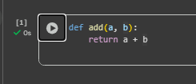
CODE CORRECTION EXPLANATION :
- Add a colon after the function header to start the code block: def add(a, b): is the correct header.
- Indent the next line to form the function body; the return statement must be inside the block.
- Final corrected code:
python
def add(a, b):
return a + b
- Missing the colon causes a SyntaxError; wrong or missing indentation triggers an IndentationError.

PROMPT 02 :

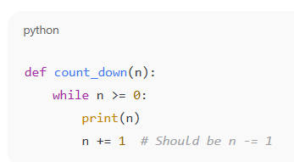
Identify and fix a logic error in a loop that causes infinite iteration.

OUTPUT :

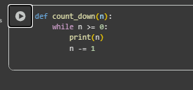

CODE CORRECTION EXPLANATION :

- The loop condition is n >= 0, so n must move downward each iteration to eventually become less than 0 and stop.
- The original code used n += 1, which increases n and keeps the condition true, causing an infinite loop.
- Replace n += 1 with n -= 1 so n decreases toward −1 and the loop terminates correctly.

PROMPT 03 :
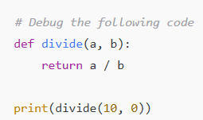
fix the Debug a runtime error caused by division by zero

OUTPUT :

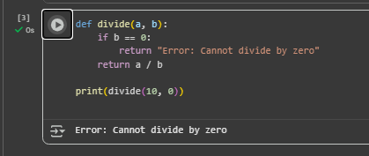

CODE CORRECTION EXPLANATION :

- Division by zero is undefined in Python and raises ZeroDivisionError at runtime.
- Fix by validating input first: if b == 0, handle it and skip division.
- Alternative: wrap the operation in try/except to catch ZeroDivisionError and recover gracefully.

PROMPT 04 :
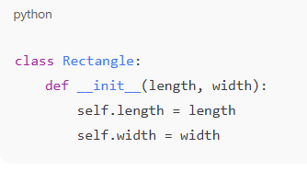
YOU NEED TO Provide a faulty class definition (missing self in parameters)

OUTPUT :
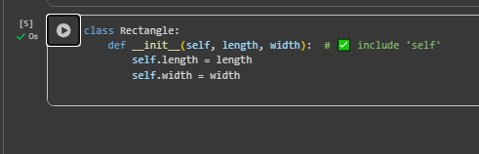

CODE CORRECTION EXPLANATION :

- The constructor was missing the first parameter self, which is the reference to the instance Python automatically passes to instance methods.
- Without self, calling Rectangle(5, 3) raises “TypeError: init() missing 1 required positional argument: 'self'”.
- Fix by adding self as the first parameter and using it to set attributes:

PROMPT 05 :
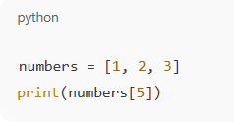
resolve the Index Error Access an invalid list index.

OUTPUT :

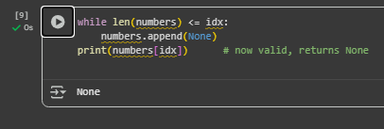

CODE CORRECTION EXPLANATION :

- Valid indices for are 0, 1, 2; 5 is out of range.
- Fix by choosing an existing index or by checking bounds with len before access.
- When adding elements, use append or insert instead of assigning to a non-existent index.

